**Q1. What is the difference between truncate, delete, drop?**

### **DELETE :**

Basically, it is aDML command. It is used to delete one or more tuples of a table. With the help of the “DELETE” command, we can either delete all the rows in one go or can delete rows one by one. i.e., we can use it as per the requirement or the condition using the Where clause. It is comparatively slower than the TRUNCATE command. The TRUNCATE command does not remove the structure of the table.

**Syntax –**   
If we want to delete the row of the table as per the condition then we use the WHERE clause,

DELETE from WHERE ;

### **DROP :**

It is a DDL command. It is used to drop the whole table. With the help of the “DROP” command we can drop (delete) the whole structure in one go i.e. it removes the named elements of the schema. By using this command the existence of the whole table is finished or say lost.

**Syntax –**   
If we want to drop the table:

DROP table ;

### **TRUNCATE :**

It is also a DDL command. It is used to delete all the rows of a relation (table) in one go. With the help of the “TRUNCATE” command, we can’t delete the single row as here WHERE clause is not used. By using this command the existence of all the rows of the table is lost. It is comparatively faster than the delete command as it deletes all the rows fastly.

**SYNTAX –**   
If we want to use truncate :

TRUNCATE;

**2. What are alias in MySQL?**

SQL aliases are used to give a table, or a column in a table, a temporary name. Aliases are often used to make column names more readable. An alias only exists for the duration of that query. An alias is created with the AS keyword.

**3. How do you display even rows of the any table?**

The simplest way to find the records with odd or even values is to check the remainder when we divide the column value by 2. A remainder of 0 indicates an even number, while an odd number points to an odd number.

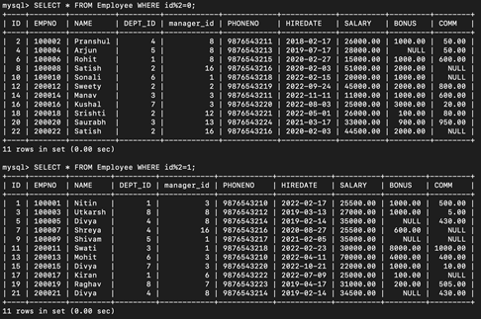

**4. How can you remove duplicates from a table(distinct and other way)**

**Remove Duplicates using DISTINCT:**

The DISTINCT keyword can be used to query for distinct rows in a table:

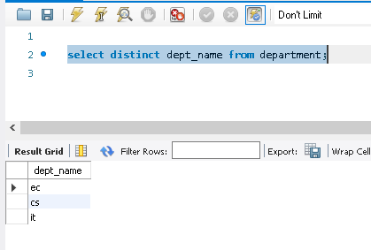

**Remove Duplicates using group By:**

The GROUP BY clause can be used to query for distinct rows in a table:

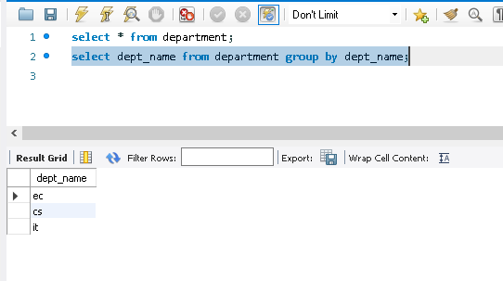

### **By using a set UNION operator:**

The set UNION operator can also be used to query for distinct rows in a table:

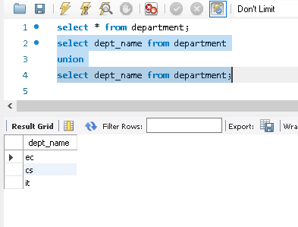

**5. How you can find 5th max salary?(Do it by all 3 ways)**

**Salaries in descending order :**

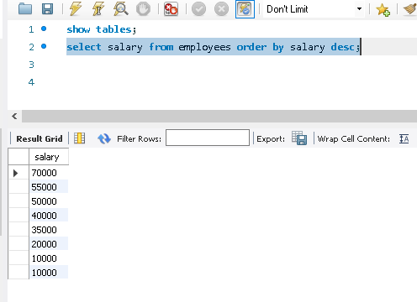

**Using Sub-Queury :**

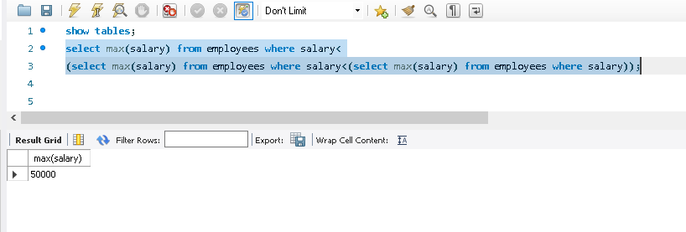

**Using Limit :**

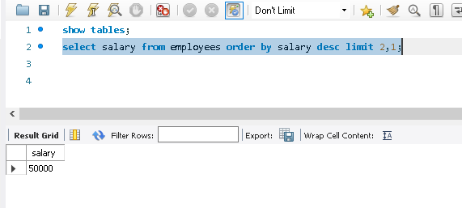

**Using Limit-Offset :**

